Carbon Reduction Plan
Supplier name:…Corax Insights Ltd……………………………………………………………….
Publication date:…21 July 2025………………………....................................................

Commitment to achieving Net Zero
Corax Insights is committed to achieving not just Net Zero emissions by 2037, but to become a zero-energy business by 2037.

Baseline Emissions Footprint
Baseline emissions are a record of the greenhouse gases that have been produced in the
past and were produced prior to the introduction of any strategies to reduce emissions.
Baseline emissions are the reference point against which emissions reduction can be
measured.
Corax Insights has not measured its baseline emissions to date.

Baseline Year: 2025
Additional Details relating to the Baseline Emissions calculations.
As a company with one active worker, based in a home office and using a single laptop, our emissions are low.
We estimate our total electricity use for the past 12 months totalled 180 kWh – one laptop and one LED lightbulb. We are on a renewable energy tariff, so carbon emissions are zero.
We use gas central heating. We estimate annual work-related heating-related gas use (based on the home office’s footprint and a 40 hour week) is 160 kWh, equating to approximately 34kg CO2.
I go into London for work-related activities at most 4 times a year. Home to London Bridge = 0.68kg CO2e per journey.
Scope 1 34kg gas central heating; 56kg from rail travel
Scope 2 2kg sending emails; 10kg web browsing.
Scope 3 0kg
Total Emissions 102kg

Emissions reduction targets
Over the next 3 years we will offset this carbon and be carbon neutral.
Carbon Reduction Projects 2025-2030
- Plant 3 trees
Between 2030 and 2037, we aim to not just become net zero, but to become a zero-energy business.
Carbon Reduction Projects 2030-2037
- Liquidate business
- Retire

Completed Energy Projects
We have already implemented the following measures
- Signing up to renewable energy tariff
- Using LED lightbulb in home office

Declaration and Sign Off
This Carbon Reduction Plan has been completed in accordance with PPN 06/21 and
associated guidance and reporting standard for Carbon Reduction Plans.
Emissions have been reported and recorded in accordance with the published reporting
standard for Carbon Reduction Plans and the GHG Reporting Protocol corporate standard
and uses the appropriate Government emission conversion factors for greenhouse gas company reporting.

NB – these conversion factors were unavailable. I used some conversion factors I found online:
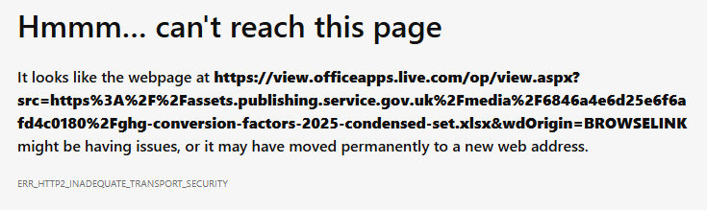

Scope 1 and Scope 2 emissions have been reported in accordance with SECR
requirements, and the required subset of Scope 3 emissions have been reported in
accordance with the published reporting standard for Carbon Reduction Plans and the
Corporate Value Chain (Scope 3) Standard.
This Carbon Reduction Plan has been reviewed and signed off by the board of directors (or
equivalent management body).
Signed on behalf of the Supplier:

…………….
Date: ……21 July 2025………………….………

